**EX.1**. This is a ……

It is……………

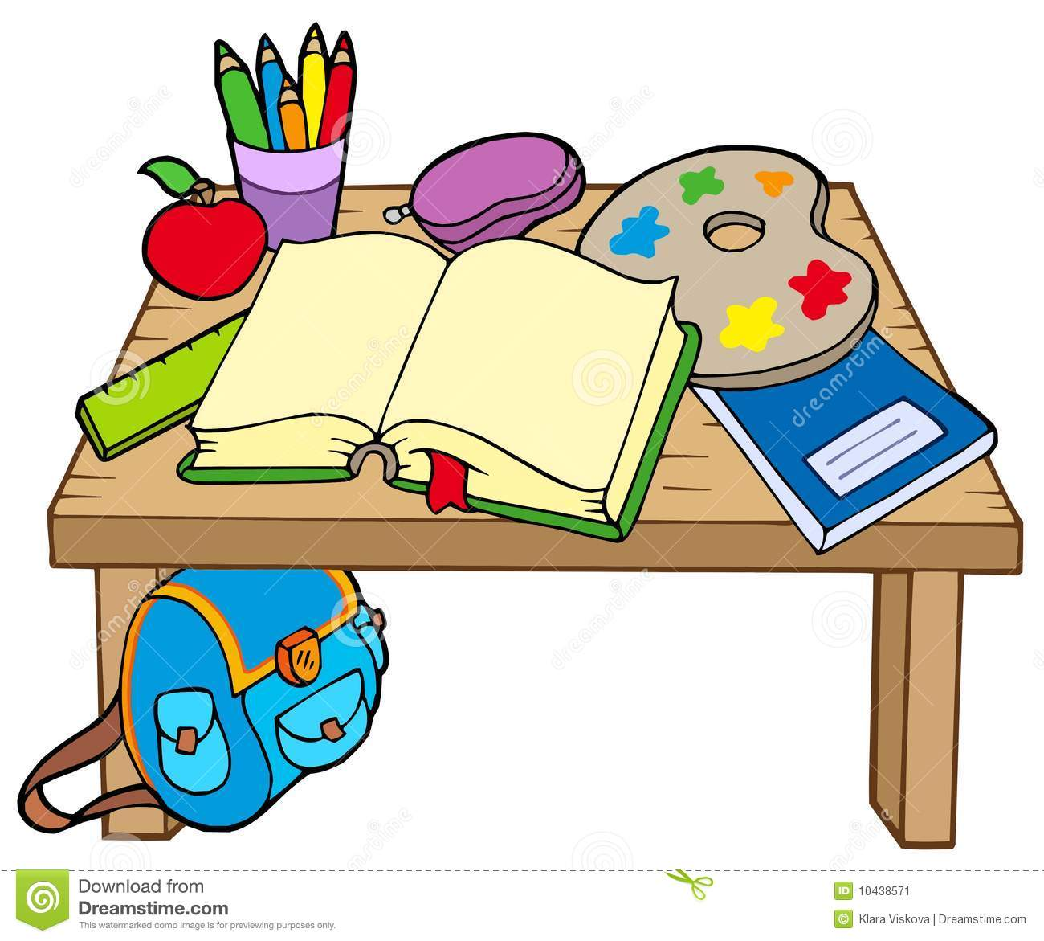

1. This is a ruler.

It is green

1. This is a copybook.

It is blue.

1. This is an apple.

It is red.

1. This is a book.

It is green.

**EX. 2**. Is this a book ?

Yes, this is.

Is it red?

No it is not.

1. This is a ruler.

Is this a ruler?

Yes, this is a ruler.

It is green.

Is it green?

Yes, it is.

1. This is a copybook.

It is blue.

1. This is a pencil.

It is red

1. This is a pencil case.

It is purple.

**Ex.3.** This is my book. /Is this my book?

It is green/Is it green?

This is his ruler/ Is this his ruler?

It is green/ Is it green?

This is her copybook/Is this her copybook?

It is blue/ Is it blue?